3-day training in
Story Links working with parents of vulnerable pupils

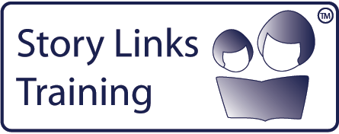
What is Story Links?
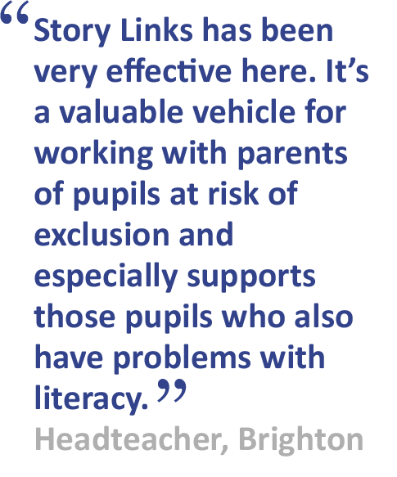
Story Links is a parent partnership intervention
to support pupils at risk of exclusion. It uses
therapeutic storywriting to address behaviour
issues of pupils with attachment difficulties,
develops parents’ emotional literacy skills and
improves pupils’ reading.

Is this training right for me?
This course is aimed at SEN teachers,
SENCOs, inclusion support teachers & school
counsellors working with vulnerable pupils
at KS 1 & 2.

What is the evidence-base?
Research funded by the TDA found that Story Links increased parental involvement in pupils’ learning, improved behaviour, and supported reading skills.
Next training session:  Dates:  Cost:  Venue: | Booking:  To apply for a place on the course, please complete the booking form below/overleaf.
About the trainer: | Delivered in collaboration with:

BOOKING FORM
Name of training:
Dates of training:
Location of training:
Please complete and return this booking form to:  Post:  School Courier:  Email:  Fax: | Cost: £00 per delegate  Refunds:  Confirmation:  Please contact [name] on if you have not received confirmation of your place by [date]
Member of Staff’s Name: | Position:
School Name:  Address: |  | School SAP Org No:  If n/a, please specify payment details
Telephone number: | Personal mobile no:
E-Mail:
Please note: All details concerning the course will be sent to this email address.
Special dietary requirements, e.g. vegetarian? Give details: | Special access requirements?  Give details.
Local authority:

